MERU SCHOOL
FORM 2 ART AND DESIGN HOLIDAY ASSIGNMENT
NOVEMBER/ DECEMBER 2025

SECTION A

  - State two functions of value as an element of art and design (2 marks)
  - Contrast between symmetrical and asymmetrical balance (2 marks)
  - Describe the role of a viewfinder in drawing (2 marks)
  - With regard to distance, mention 3 parts of a scenery (3 marks)
  - Distinguish between the terms hue and pigment (2 marks)
  - Explain the term wash as it relates to painting (2 mark)
  - Distinguish between raw edge and selvedge in weaving (2 marks)
  - List 2 factors that determine the type of pendant (2 marks)
  - Define the term montage (2 marks)
  - Distinguish between structure design and applied design in fabric decoration (2 marks)
  - Name the two resist techniques in fabric decoration (2 marks)
  - The picture below is of a wall hanging created using batik technique. Study it.
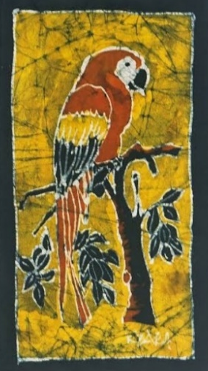
Which is the most preferred method of removing wax from such a work. Give a reason (2 marks)
  - Give 2 reasons for using a double container to melt to melt wax (2 marks)
  - Identify the unique characteristic tritik technique in fabric decoration (1 mark)
  - Name the two common defects in weaving (2 marks)

  - The illustration below represents a technique in lettering. study it and answer the question that follow;

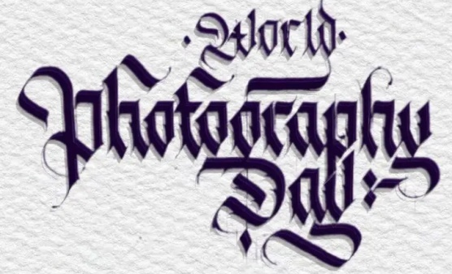
- identify the technique (1 mark)
ii. What distinguishes this technique from the others (1 mark)
  - Distinguish between visual adjustment and mechanical adjustment methods as ways of spacing in lettering (2 marks)
  - Describe two ways of creating harmony in pictorial compositions (2 marks)
  - Study the illustration presented below and answer the questions that follow;
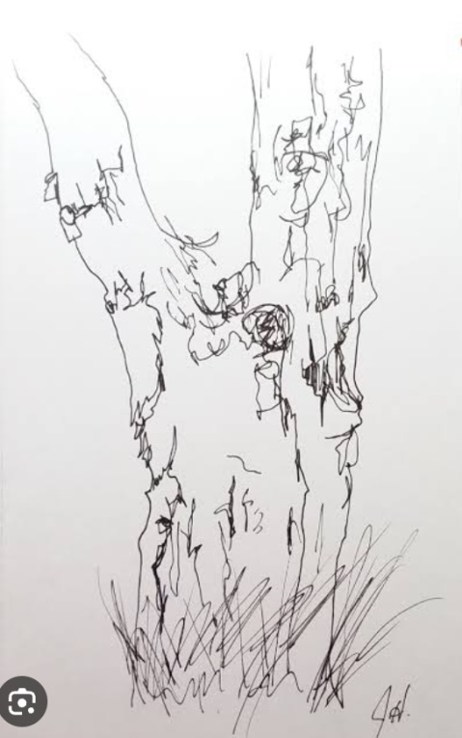

Identify and state the importance of this type of illustration in drawing (2 marks)
  - What is the function of sizing in oil painting (2 marks)
  - Differentiate between applied and structured design in fabric decoration (2 marks)
  - With reference to the illustration below, explain what you understand by modelling a form using stippling technique (2 marks)
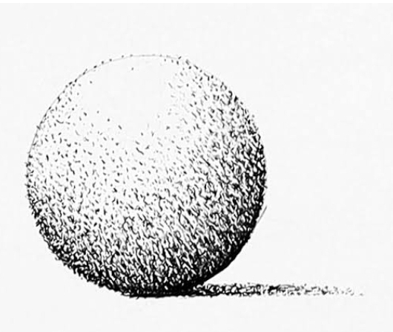

  - Highlight one reason why bees wax and paraffin wax are mixed during the batik process (2 marks)
  - Distinguish between a tjap and a tjant both of which are equipment used in batik (2 marks)
  - State two reasons for washing the fabric before dyeing (2 marks)

SECTION B
Answer ALL questions in the spaces provided
- The illustration below represents a tool used in fabric decoration. Study it.
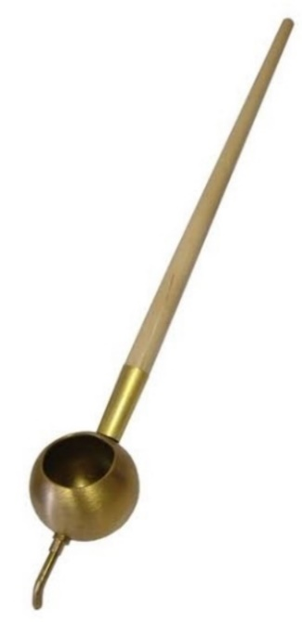
Z
Y
X

- What is the name of the tool? (1 mark)
- What advantage does this tool have over the other tools used for the same purpose (1 mark)
- Name the parts labelled X,Y and Z (3 marks)
- The illustration below represents a process in tie and dye. Study it.
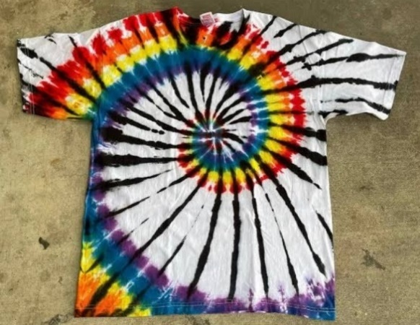
- What is the name of this particular process (1 mark)
- Outline 4 main steps involved in the process (4 marks)
- In the space provided below illustrate circular twinning (5 marks)

- Describe the five unique characteristics of collage (5 marks)
- Describe the unique qualities of the following weave structures
  - Warp faced weave structure (2 marks)
  - Weft faced weave structure (2 marks)
  - Open work weave structure (2 marks)
- Use illustrations to explain each of the following tapestry joints
  - Slit (2 marks)

  - Interlocking (2 marks)

- A form 2 art and design student has approached you to assist them in a project about decorating a t-shirt in t colours using marbling technique. Describe five key steps you would insist on. (5 marks)
- State five guidelines observed when drawing a scenery from observation in two point linear perspective (5 marks)

- efine the term chroma (1 mark)
- While providing precise examples, distinguish between monochromatic colour scheme and analogous colour scheme (4 marks)
- The illustration below represents a technique in weaving;
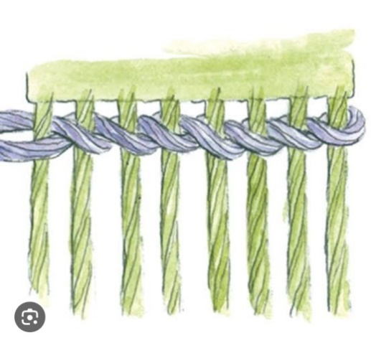
- Identify the technique (1 mark)
- Name two natural and two synthetic fibres used in weaving (4 marks)

SECTION C
Answer ALL questions in the spaces provided
- Outline 5 factors to be considered when designing a book cover (10 marks)
- Mentioning the materials, tools and equipment, discuss the steps of making a collage pictorial composition from imagination (10 marks)

  - Define the term collage (2 marks)
  - State 3 characteristics of a collage (3 marks)
  - Mentioning the materials and tools, describe the process of making a collage composition from imagination (10 marks)

  - Explain each of the following functions of a woven item
    - status symbols (1 mark)
    - aesthetics (1 mark)
  - Outline three factors to be considered when selecting the length of warps to be used on a heddle loom (3 marks)
  - With the aid of well labelled illustrations, describe the process of warping a rigid heddle loom (10 marks)
Practicals:

  - Guided by the theme sports, generate 15 stick figures in the space provided below (15 marks)
  - In the space provided below draw a self portrait in ¾ view (5 marks)
  - Working with the Head units, come up with a sketch detailing the proportions in the human figure (5 marks)
  - Carry out study drawings of the hand (10 marks)

